Linux material

--==================================

Software :it is a collection of programmes.

eg:c,c++,java

1)System s/w :It interacts with h/w components eg:OS

2)application s/w:Application development eg:

OS:interface betwen h/w and application s/w.it is aplace where we can run application s/w.

we have two types of operating systems.

1)CUI-->Command Line user interface

a.singele user os ->Ms DOS

b.Multi user OS -->Linux,Solaris,HP-UX

2)GUI-->Graphical user interface

a.singele user os ->Win95,win98

b.Multi user OS -->winxp,7,8,10.Linux and solaries

Features of Linux:

1)Multiuser

2)open source

3)Multiple programs

4)Security-->it provides authentication features

5)portable.

6)Programming -->Linux provides a shell which can be used to execute command of the os.

shell works like programming language.

Linux architecture

===================

1)Hardware --All peripheral devices RAM,CPU,HDD

2)Kernel core component of operating system.It will interact directly with hardware.

3)Shell It is an interface between user and kernel.Takes command from user and passes to kernel.

4)Utilities

Linux flie system:

file system means how the data is stored in to device and how data is retrieving.

A specific type of data storage format, such as EXT3, EXT4, BTRFS, XFS, and so on. Linux supports almost 100 types of filesystems, including some very old ones as well as some of the newest. Each of these filesystem types uses its own metadata structures to define how the data is stored and accessed.

entire file system is like a tree structure.

/--->root

1

/

This is the root directory which should contain only the directories needed at the top level of the file structure

2

/bin

This is where the executable files are located. These files are available to all users

3

/dev

These are device drivers

4

/etc

Supervisor directory commands, configuration files, disk configuration files, valid user lists, groups, ethernet, hosts, where to send critical messages

5

/lib

Contains shared library files and sometimes other kernel-related files

6

/boot

Contains files for booting the system

7

/home

Contains the home directory for users and other accounts

8

/mnt

Used to mount other temporary file systems, such as cdrom and floppy for the CD-ROM drive and floppy diskette drive, respectively

9

/proc

Contains all processes marked as a file by process number or other information that is dynamic to the system./proc is very special in that it is also a virtual filesystem. It's sometimes referred to as a process information pseudo-file system. It doesn't contain 'real' files but runtime system information (e.g. system memory, devices mounted, hardware configuration, etc)

10

/tmp

Holds temporary files used between system boots

11

/usr

Used for miscellaneous purposes, and can be used by many users. Includes administrative commands, shared files, library files, and others

12

/var

Typically contains variable-length files such as log and print files and any other type of file that may contain a variable amount of data

Contains variable data like system logging files, mail and printer spool directories, and transient and temporary files. Some portions of /var are not shareable between different systems. For instance, /var/log, /var/lock, and /var/run. Other portions may be shared, notably /var/mail, /var/cache/man, /var/cache/fonts, and /var/spool/news. Why not put it into /usr? Because there might be circumstances when you may want to mount /usr as read-only, e.g. if it is on a CD or on another computer. '/var' contains variable data, i.e. files and directories the system must be able to write to during operation, whereas /usr should only contain static data. Some directories can be put onto separate partitions or systems, e.g. for easier backups, due to network topology or security concerns. Other directories have to be on the root partition, because they are vital for the boot process. 'Mountable' directories are: '/home', '/mnt', '/tmp', '/usr' and '/var'. Essential for booting are: '/bin', '/boot', '/dev', '/etc', '/lib', '/proc' and '/sbin'.

13

/sbin

Contains binary (executable) files, usually for system administration. For example, fdisk and ifconfig utlities

14

/kernel

Contains kernel files

15

The /root directory is the home directory of the root account. It is also referred to as the root user's home directory (and not as the root directory).

Users ,Groups and Permissions

====================================================

$ -->User mode

#-->Sudo user or admin

Ubuntu host name is :ubuntu@ec2ip

Linux :ec2-user@ec2ip

first we will generate one pem file

If you need to add a root user password temporarily:

1. Connect to your EC2 instance running Linux by using SSH.

2. Assume root user permissions by running the following command:

$ sudo su

3. Next, run the following command to create a password for the root user:

# passwd root

4. When prompted, enter your temporary root password, and then enter it again to confirm it.

Note: This command must be run as the root user.

After you finish the task that requires a temporary root password, delete the root password by running the following command:

# passwd –l root

adding user

==========================

$ sudo su

acts as switch user

#adduser syam

1)here we are creating new user so in /home/syam(this directory created automatically)

2) and inside this directory we have 3 files .bash_logout,.bashrc,.profile are created automatically.

and

3)in /etc/group -->in this group file automaticaly one group is added i.e syam

if we have to find something in linux we can use grep command.

#grep syam /etc/group

4) A mail spool is creating under //var/spool/mail/username

#cat /etc/passwd

[username]:[x]:[UID]:[GID]:[Comment]:[Home directory]:[Default shell]

Fields [username] and [Comment] are self explanatory.

The x in the second field indicates that the account is protected by a shadowed password (in /etc/shadow), which is needed to logon as [username].

The [UID] and [GID] fields are integers that represent the User IDentification and the primary Group IDentification to which [username] belongs, respectively.

The [Home directory] indicates the absolute path to [username]’s home directory, and

The [Default shell] is the shell that will be made available to this user when he or she logins the system.

#cat /etc/group

[Group name]:[Group password]:[GID]:[Group members]

[Group name] is the name of group.

An x in [Group password] indicates group passwords are not being used.

[GID]: same as in /etc/passwd.

[Group members]: a comma separated list of users who are members of [Group name].

# usermod --expiredate 2014-10-30 tecmint-->setting expiry date to user

default directory permissions.

default file permissions.

switch user

*sudo -u syam-->syam is user

*id userid

userid groupid and groups will get

#groups userid-->it will list ,all groups he is associated

#sudo usermod -g (destination primary group),username --->changing user default groups

if a particualr user not acts as sudo then we use

we shoold exit from current user user login as admin

and this user in suo file

#sudo visudo

we ahould add users in that file

:wq!

aading users to other groups

sudo groupadd mynewgp

sudo usermod -a -G mynewgo dev

here -a >Adding

-g > adding to Group

mynewgp -->groupname

dev-->userid

-g means changing default group

-G-->adding to secondary group

#sudo usermod -a -G g1,g2,g3 user -->adding user to multiple groups

i have a requirement to add new and at the same time assigning to user

#sudo useradd -G Groupname syam

permissions

=====================

$ chmod u+rwx,g+rwx,o+rwx file1.txt

u -->user level,g-->group level,o-->others ,a-->all

$ chmod a+rw file1.txt

$chmod u=r file1.txt

octal notation

==========

r-->4

w-->2

x-->1

chmod 555 file1.txt

chmod 77 file1.txt-->077

chmod 7 file1.txt-->007

default permission depends on umask value .

if umask is 002.

for directory 777-002=775

for file 666-002=664

umask-->user mask or user file creation mask.

umask, as the man page says, stands for User file creation mask which is used for determining the default permission for a new file creation. The new file creation could either be a file creation through a normal process or a file copy. umask command is a shell built-in meaning it is an internal command.

ps -->currnet processses are running

The ps (i.e., process status) command is used to provide information about the currently running processes, including their process identification numbers (PIDs).

To view all the running processes use either of the following commands:

ps -A

ps -e

to kill specific process id then

kill -9 pid1

kill -9 pid1 pid2 pid3 -->multiple kill processes and 9 is sure to kill

----------------------------------------------------------------------------

ls command

sy

ls -a

date

date +%D(d,m,y,Y,H,M,S)

cal

cal 2018

cal year range between 1 to 9999

mv x1 x2

x1 directory moved to x2

to remove a directory it should be empty

Fdisk

============

?Fdisk?(fixed disk or format disk) is a text-based command-line utility for viewing and managing hard disk partitions on Linux. Using fdisk you can view, create, resize, delete, change, copy and move partitions.

Cat Command:this command is used to view the file content or create a file.

Cat < syam1.txt or cat syam1.txt 🡪view file content.

Cat > syam1.txt 🡪creating new file with syam1.txt in editable mode.

For redhat linux username is ec2-user.

We will display multiple files.

Cat file1 file2 file3.

Touch command:it will create an empty file.

In linux a file name starts with . means it’s a hidden fie.

Touch .file1 .file2

CP command:copy of one file content to another file.

Cp file1 file2🡪file1 is source ,file2 destination

File1:file1 data

File2:file2 data

After above command ,file2 content is file1 data.

Cp –I file1 file2 --🡪it will confirmation before override.

Mv command:renaming a file.

Mv file1 file3-🡪it will create new file with file3 and copy file1 content into file3 and finalyy remove file1.

Mv –I file1 file3🡺it will ask confirmation before rrenaming.

Uname –a:it will show info about kernel and its release date version and so on.

rm:remove files. 🡪rm file1

rm file1 file2 🡪multiple files removing

cmp it show comparison between twon files.

Diff it will show difference betyween two files.

If its directory we will use option with –R for cp and mv commands.

-R -> recursively.

Wildcards characters.

Ls:ls f*🡪file name starting with f

Ls *f:fle name ending with f.

Ls ????*🡪all files with at least 4 characters and followed by any characters.

Ls f???*🡪first letter with f and then 3 characters and folllwedby any.

Ls file[1-9]🡪file ranging from 1 to 9.

Ls file[a-z]🡪file ranging from ato z.

Ls file[!1-3]🡪file ranging other than 1 to 3.

Ls {f*,L*}🡪files startng with f and as well as starting with L.

The above commands we can use with CP and RM also.

Rm file[1-9]

Cp file[1-9] ~/Dir1/

In redhat linux we don’t have gedit command so we should install before using.

sudo yum install gedit

gedit is the official text editor of the GNOME desktop environment. Generally, in a server, there is no desktop environment installed or needed. Therefore, gedit can't start and display.

**GNOME** is a **desktop environment** composed of free and open-source software that runs on Linux and most BSD derivatives. **GNOME** was originally an acronym for GNU Network Object Model Environment, but the acronym was dropped because it no longer reflected the vision of the **GNOME** project. **GNOME**is developed ...

Wc command:word count command

Wc file1

6 24 114 file1

6🡪lines. 24 🡪words and 114 characters.

Wc –l 🡪only lines

Vi Editor:

To edit any file we will use VI editor.we have lot of options to to modify any file.

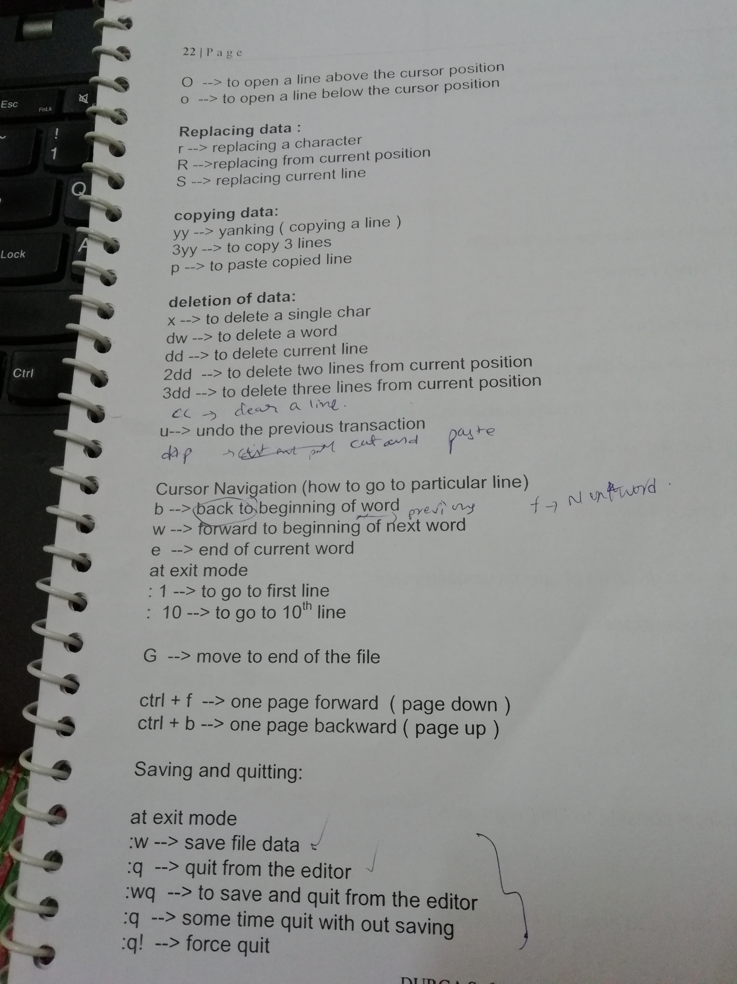

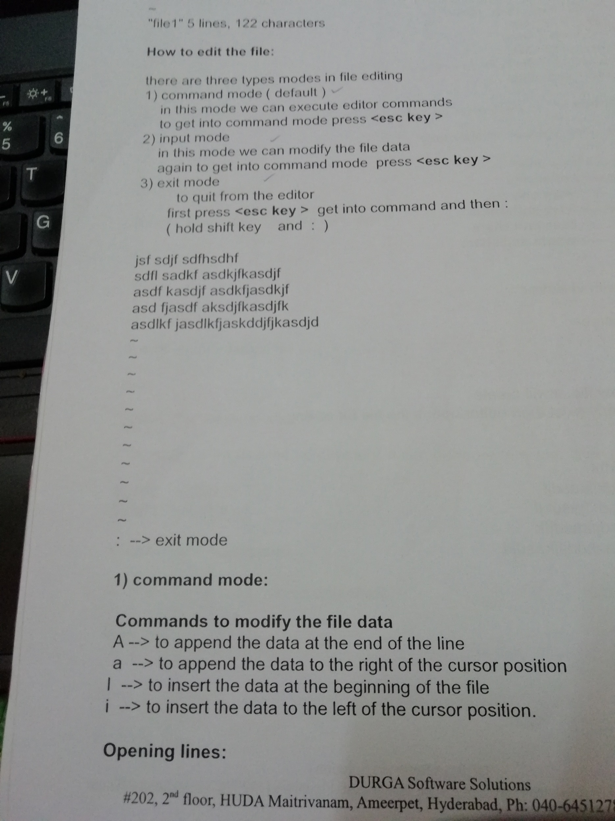

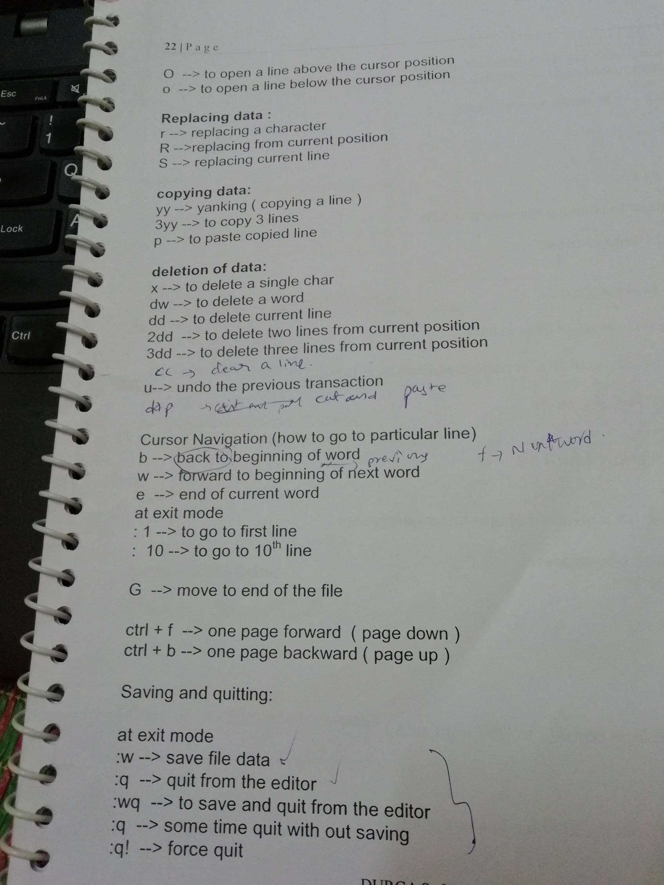

:set nu🡪tto set line numbers in the editor. 🡪to stop line numbers.

Set nonu.

:!<linux commands>🡪!date

Pipe command:pipe is used to changing the output of jobs.

The Pipe is a command in Linux that lets you use two or more commands such that output of one command serves as input to the next. In short, the output of each process directly as input to the next one like a pipeline. The symbol '|' denotes a pipe.

File4:hi all file4.

Now I found hi word in how many lines.

Cat file4 | grep hi |wc –l

Who |wc –l

Cat >> file4 means append new data to the old one.

Cat file1 > file3

It creates file3 (if its nothere) and overwrites file1 data into file3.

Cat file1 >> file3

Append data into file3 of file1.

Head command:to display beginning lines of file.

Head file1🡪it will display all lines of data.

Head -4 file1🡪it will display first 4 lines of file.

Head -4 file1 > result.txt

Tail command:to display ending lines of file.

Tail file1

Tail -1 file1

Tail -2 file1 >result.txt

I want lines in the middle like I have file with 10 lines but I want line number 2 to 6.so

Head -6 file1 | tail -5 >res.txt

Tee command:to get the data from pipe and display as well as as storing into text file.

If we want to save and show at the same time the we use tee command.

Head -6 file1 | tail -5 | tee res.txt

Grep command:to search something in a file we will use grep command.

Grep hi file1.

Grep –n hi file1🡪including line numbers.

Grep –v hi file1->other than hi lines

Grep –I hi file 🡪ignore case sensitive.

Grep –c hi file🡪no .of line with hi word.(grep hi file1|wc -l)

Grep –o hi file1🡪only matched woprd.

Grep –R hi file1🡪including sub directories.

Grep -4 hi file1🡪display 4 lines before and after.

command:whenever we are having large amount of files then we will do zip those files and sen those zip files to destination,at destination side they will do unzip and extract those files.

We can do it in multiple ways.

1. Tar –cvf myucustoms.tar ucustoms(ucustoms directory archiving as myucstoms.tar)archiving
2. Gzip myuctoms.tar(mycystoms.tar.gz) compressing
3. Gunzip mycustoms.tar.gz(myucustoms.tar)uncompress
4. Tar –xvf myucustoms.tar (ucustoms)un archieve

Tar –rvf myucustoms.tar ucustoms(appending to existing tar)

C->Create x🡪extract v🡪verbose(security protocol),f->files.

Tar –czvf myucustoms.tar.gz ucustoms

Tar –xzvf myucustoms.tar.gz

Tar –xzvf myucustoms.tar.gz –C ~/TaregLocation(if we want specify any particular location).

Umask:by default 002

Default permission of directory is 775 (777-002)

Defulat permission of file is 664(666-002).

We can change umask value simply

Umask 003

Now umask value will change to 003.

Then default permission of directory is 777-003=774

Defulat permission of file is 666-003=663.

Processes:ps –ef

All processes.

Kill -9 pid1 pid2 pid3

-9 sure to kill

Shell:to interact with kernel ,we need one interface i.e called shell.interface b/w user and kernel.

We have different types of shell.

Bourne shell:the most basic shell available on all unix systems.

Korn shell:based on the bourne shell enhancements.

C shell:similar to C programming language in syantax.

Bash shell:bash bourne again shel combines the advantages of korn shell and C shell.it is default shell on most linux distributions.

Tcsh:similar to C shell.

Echo $0

Types of shell using in OS.

$history🡪it will show list of commands we are usied in this shell.

Bash shell:

When we logon to a shell a no.of variable and settings are configured for your shell.the fiels that are most commonly used by bash are:

1)/etc/profile(admin level)

It provides system wide default environment variables.Typically this sets up the umask,LogName,and mail directories etc.it is can also be used to change the default command search PATH for all userson the system.

2)~/.bash_profile

This provides user specific environemt variables,and is often used to add local search paths onto the PATH.this is called after the /etc/profile script.

3)~/.bashrc

This file is called non-interactive shells,nad is normally called from the ~/.bashrc_profile for interactive shells.it is normally used for setting up aliases and other commands that are run during the start up.

4)~/.bashrc_logout

It is called when user logs out of the interactive shell.

Echo command we are using for displaying text.

Shell scripting:we will create a file name extension with .sh then kernel will will understand it’s a shell script.

1)Create a file with file1.sh

Edit that file and write all commads

2)change the file permission because it’s a shell script not executed directly so we need to specify execute permission to this file to user level.

Chmod 766 file1.sh

3)execute that script

./file1.sh

Command quotations are used to substitute the result of the command into text.

In shell script file

Echo “today date is `date +%D`”

Echo “total no.of lines in file f1 has `wc –l file1`”

Env 🡪it will give all environment variable.

Variables:we have two types of variables

1)System variables(Environment variables)

2)user defined variables.

And these varibales are again devided into 3 .

Local variables.-->only for present session (present termianl)

User level(throught user sessions)~/.bashrc

System level.(trough out system)

A=10

B=20

Echo $A

Echo $B

Syampath=~/newd/DD

Echo $Syampath--🡪/home/ec2-user/newd/DD

If we wanat user level variables then we will keep it in ~/.bashrc file.

At end of the file

Export a=10

Export b=20.

And go to terminal and take new session and type echo $a

We will get 10.

And we have the optioin to pass parameters to shell script at the tiume of execution.

Vi file1.sh

date

echo "date command"

echo $PATH

echo $USER

echo "this is user of $USER"

echo "today date is `date +%D`"

echo "total no.of lines of file is `wc -l f1`"

echo "nely ccreated varibles"

echo "radhi is $radhi"

echo "syam is $syamgadu"

#date command executing

Parametrs script;

echo "no.of parameters count: $#"

echo "Script name:$0"

echo "first parameter is :$1"

echo "second parameter is :$2"

echo "all parameters:$*"

$ ./newscript.sh hello syam rash

Output: no.of parameters count: 3

Script name:./newparamscript

first parameter is :hello

second parameter is :syam

all parameters:hello syam rash

$#-🡪parameters count

$0🡪script name

$1🡪first parameter

$2🡪second parameter

$*🡪all parameters

[ec2-user@ip-10-138-77-26 shellscript]$ name=`date +%d-%m-%Y-%H-%M-%S`

[ec2-user@ip-10-138-77-26 shellscript]$ echo $name

08-04-2018-14-08-23

cat>$name.txt

hi boss how are u

[ec2-user@ip-10-138-77-26 shellscript]$ ls

08-04-2018-14-08-23.txt f1 newparamscript shellscript.sh

Newshellscript.sh

echo "no.of parameters count: $#"

echo "Script name:$0"

echo "first parameter is :$1"

echo "second parameter is :$2"

echo "all parameters:$*"

sirji=`date +%d-%m-%Y-%H-%M-%S`

echo "babu ee file linux lo create avtundi $sirji" >>$sirji.txt

echo "babu ee file unix lo create avtundi $sirji" >>$sirji.txt

exit 0

here every time one new file create with date and time.

Reading a variable from keyboard: read a b c

10 20 30

Echo $a

10.

Readonly variable we cant edit.

[ec2-user@ip-10-138-77-26 shellscript]$ x=100

[ec2-user@ip-10-138-77-26 shellscript]$ readonly x

[ec2-user@ip-10-138-77-26 shellscript]$ x=200

-bash: x: readonly variable

[ec2-user@ip-10-138-77-26 shellscript]$ readonly --it will show all readonly variables.

declare -r BASHOPTS="checkwinsize:cmdhist:expand_aliases:extquote:force_fignore:histappend:hostcomplete:interactive_comments:login_shell:progcomp:promptvars:sourcepath"

declare -ir BASHPID

declare -ar BASH_VERSINFO='([0]="4" [1]="2" [2]="46" [3]="2" [4]="release" [5]="x86_64-redhat-linux-gnu")'

declare -ir EUID="1000"

declare -ir PPID="1320"

declare -r SHELLOPTS="braceexpand:emacs:hashall:histexpand:history:interactive-comments:monitor"

declare -ir UID="1000"

declare -r x="100"

declare -r y="20"

[ec2-user@ip-10-138-77-26 shellscript]$ vi readingdatakeyboard.sh

echo "emplyee detaills"

echo "\nPlease Enter employee name"

read empno

echo "\nplease enter emp salary"

read esal

echo "\nplease enter empid"

read empid

echo $empno:$esal:$empid

echo $empno:$esal:$empid>>$empid.txt

if we have to do any mathematical operations we should use expr command.

$expr 10 / 3

Expr $a + $b

Maths.sh

echo "enter two numbers"

read a b

echo "addtion is :`expr $a + $b`"

echo "subtraction is :`expr $a - $b`"

echo "multiplication is :`expr $a \* $b`"

echo "divison is :`expr $a / $b`"

exit 0

enter two numbers

200 50

addtion is :250

subtraction is :150

multiplication is :10000

divison is :4

if condition:

ifcond.sh

echo enter two numbers

read a b

if [ $a -gt $b ]

then

echo "a is bigger"

else

echo b is bigger

fi

exit 0

[ec2-user@ip-10-138-77-26 shellscript]$ ./ifcond.sh

enter two numbers

88 768

b is bigger

operators:

+,-,\*,/,%

-gt,-ge,-lt,-le,-eq,-ne

Logical

-a ,-o,!